
OSPF Routing and Configuration

Objectives
UnderStanding OSPF
Learn how To Config Routers With OSPF Advertise directly connected networks using OSPF
..Verify OSPF configuration using different show commands

Equipment / Program Requirements:

eNSP
Cisco Packet Tracker

Experiment Setup:
The network topology consists of two routers connected together using an
.Ethernet link
.Each router is connected to a PC to form two different LANs

.Router 1 is connected to PC1 -
.Router 2 is connected to PC2 -
.The two routers are connected using a direct link -

:IP addressing is configured as follows Network between routers: 11.0.0.0/30 -

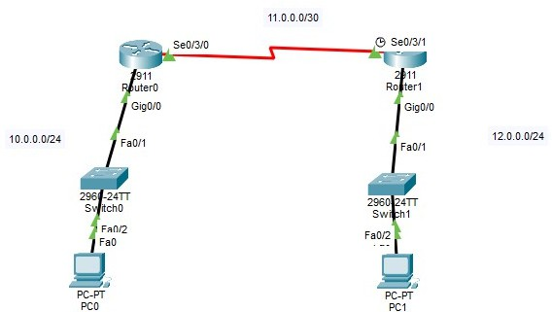
LAN 1: 10.0.0.0 /24 - LAN 2: 12.0.0.0/24 -
OSPF is configured on both routers in Area 0 to enable dynamic routing and
.allow communication between the two LANs

Simulation Results:
Cisco Packet Tracker Topology:

Router1 Configuration:

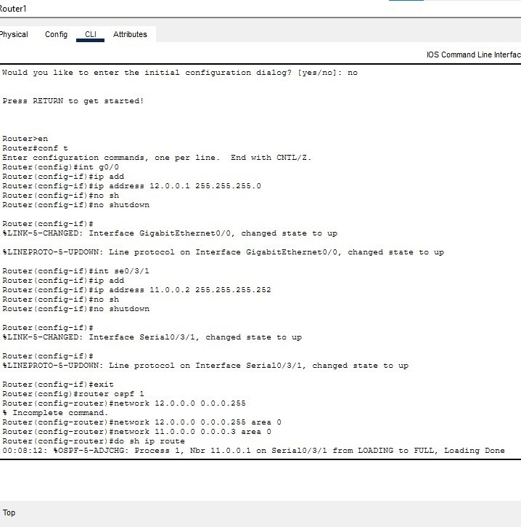

Router1 Route Table,OSPF, LSDB:

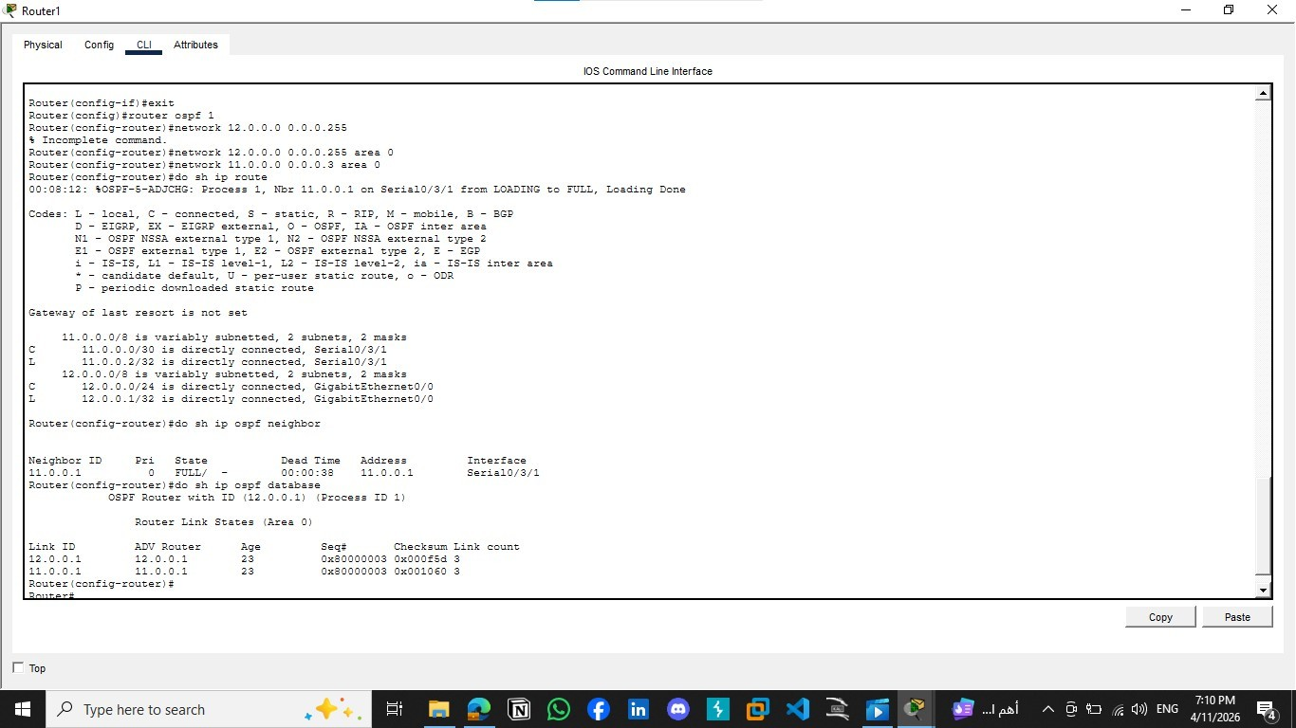

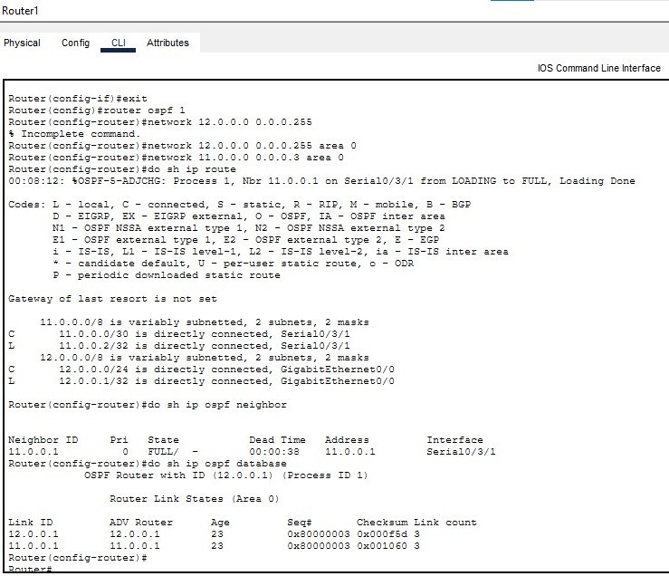

Router 0 Configuration:

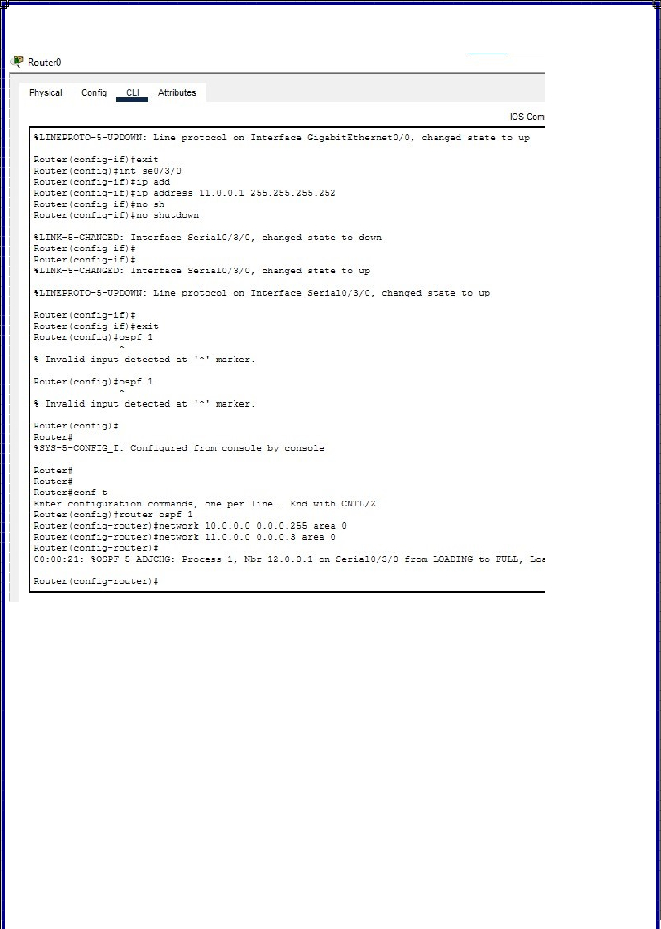

Router 0 Route Table , OSPF , LSDB:

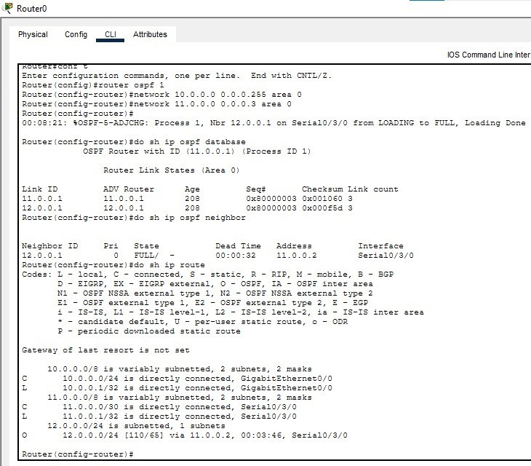

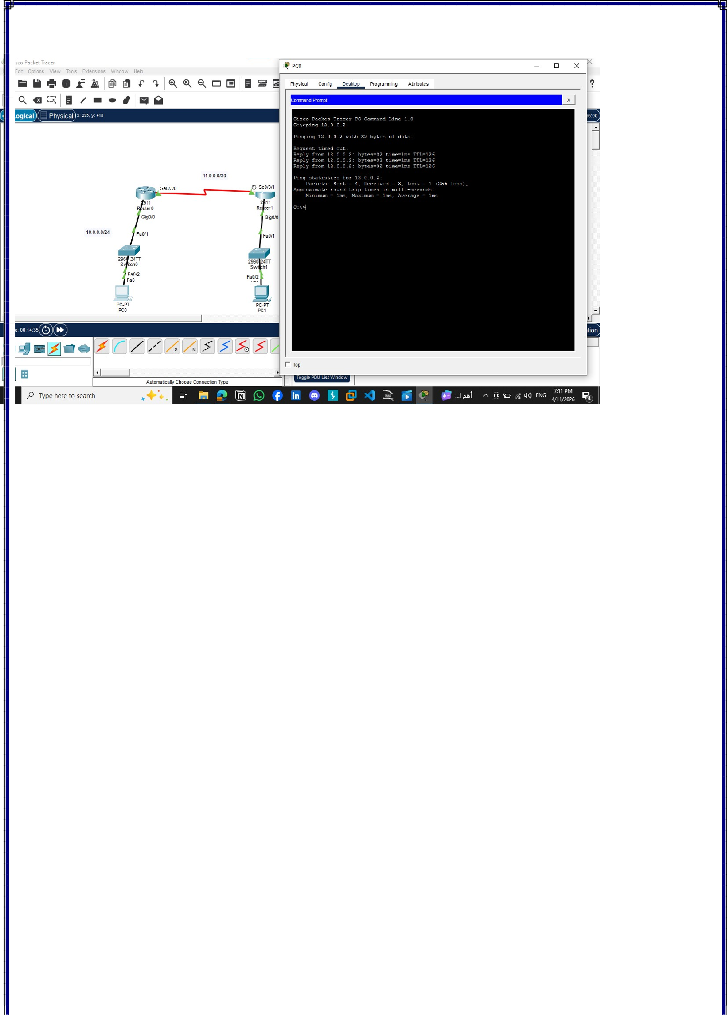
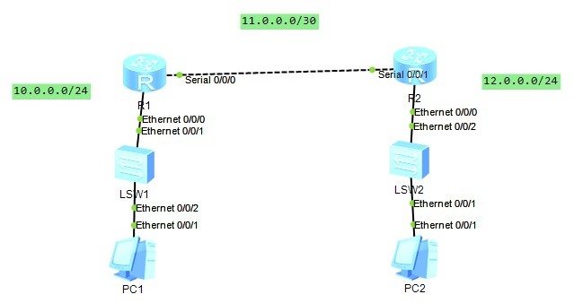

eNSP:
Topology:

Configuration On R1:

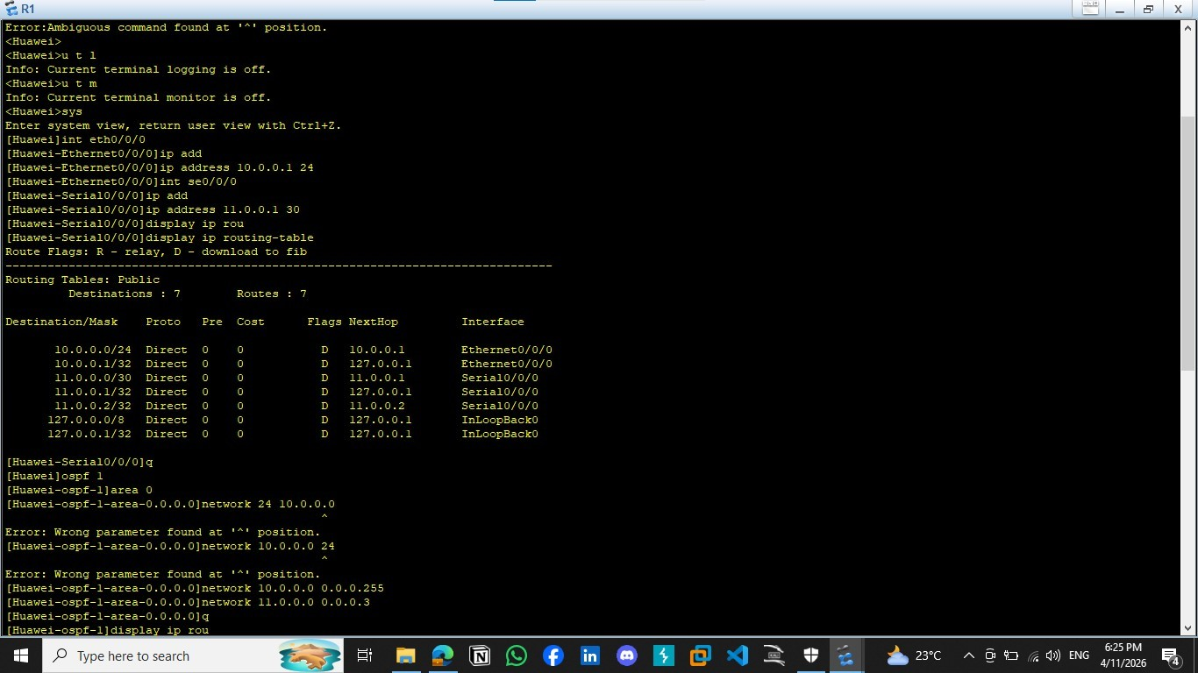

Configuration On R2

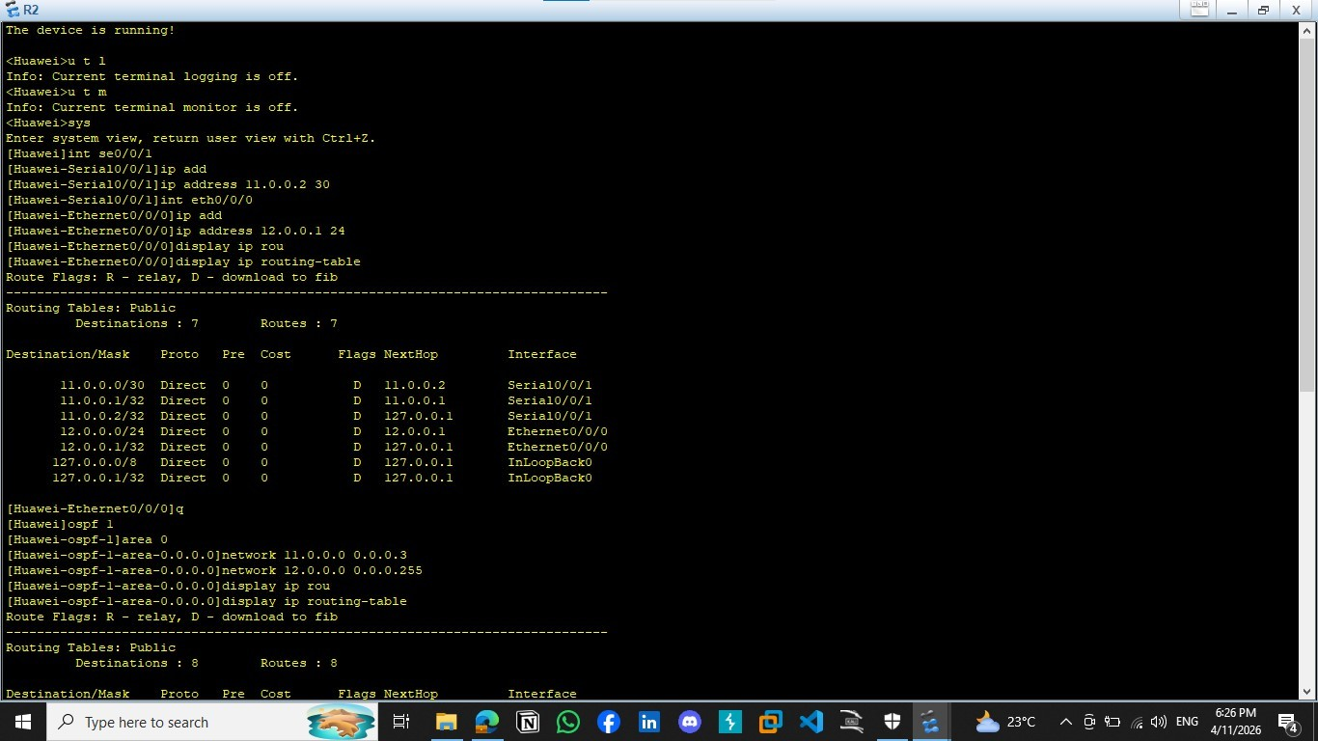

Routing Table For R1

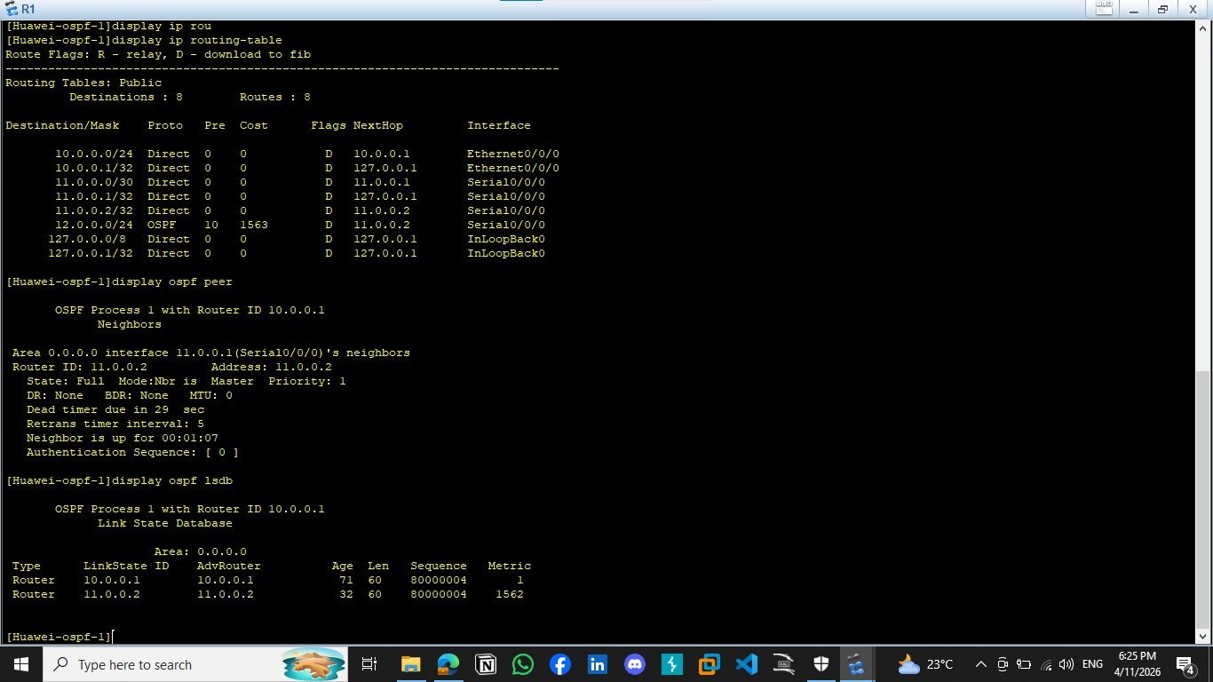

Routing Table For R2

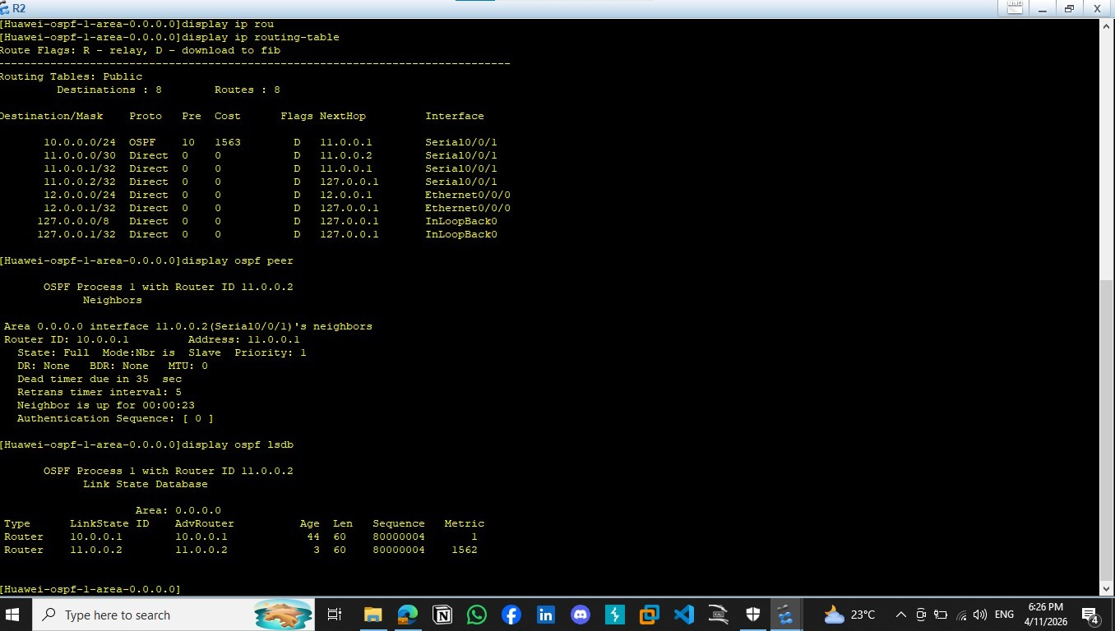

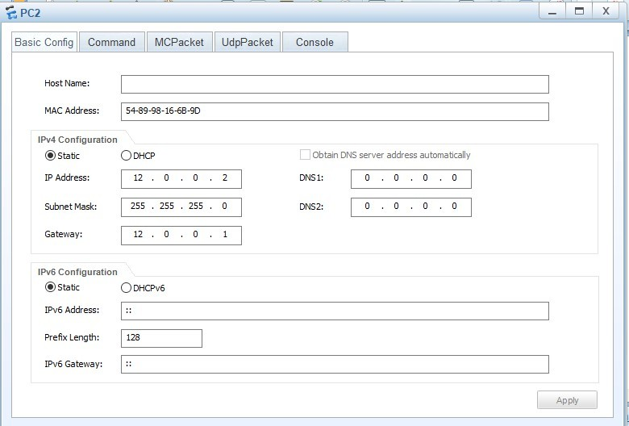
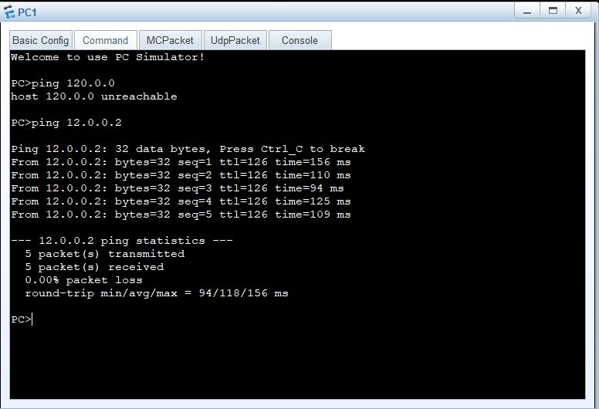

Conclusions:
The OSPF protocol allowed automatic route exchange between routers, which enabled successful communication between different LANs
..OSPF is more efficient than static routing in large and complex networks

